**Connecting Virtual Sensors to Azure IoT Hub**

**Prerequisites**

* Microsoft Azure account and subscription
* Visual Studio 2017

**Part 1 - Create an IoT Hub resource**

1. Go to **Azure** **Portal** (portal.azure.com).
2. Click **+ Create a resource** -> Search for **IoT Hub** -> Select the first **IoT Hub** option -> Click **Create**.
3. Enter the following information:

* **Name**: The name of your IoT Hub must be globally unique
* **Pricing and scale tier**: F1 – Free
* **Subscription**: Choose your subscription
* **Resource group**: Create a new resource group. Give it a name.
* **Location**: Australia Southeast

A Resource group is similar to a folder that contains files. In this case, your ‘files’ are your resources – one of them is your IoT Hub.

Click **Create**.

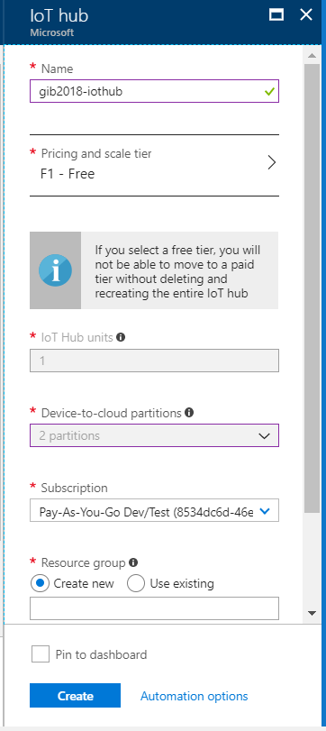 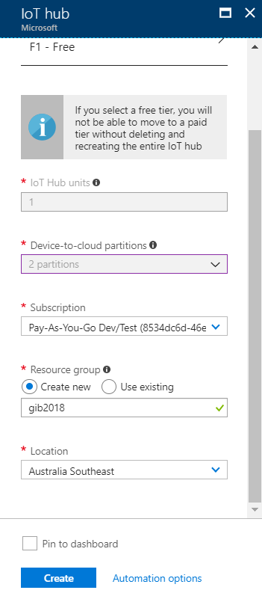

1. Once deployment is finished, go to your IoT Hub. **Resources** **groups** -> your Resource group -> your **IoT** **Hub**.
2. Add 2 devices – humidity and temperature. From your **IoT** **Hub** screen -> Go to **IoT Devices** -> **+** **Add**.

* For the Device ID, enter **humidity**. Click **Save**.
* Again, click **+ Add**. Do the same as above for **temperature**.

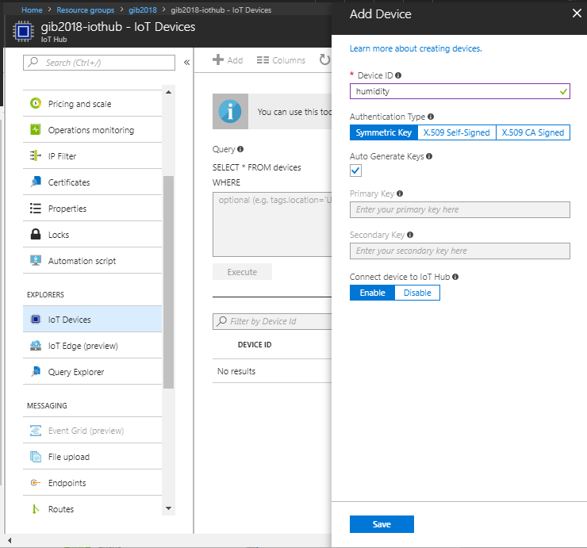

**Part 2 - Create a Blob Storage**

1. Click **+ Create a resource** -> **Storage** -> **Storage account – blob, file, table, queue**.

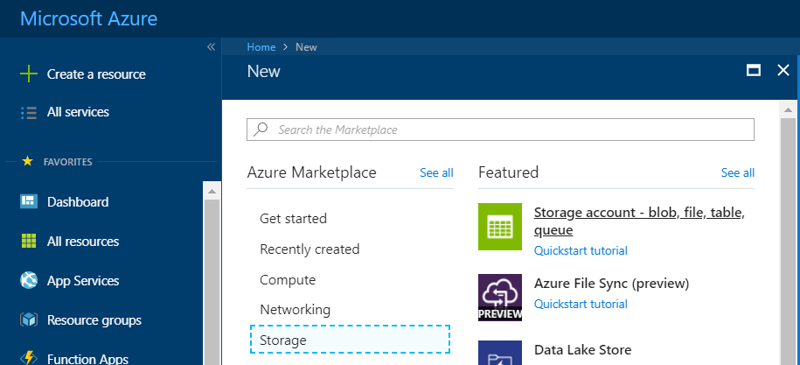

1. Give your new storage account the following information:
   * **Name**: The name of the storage account must be globally unique.
   * **Account** **kind**: Blob storage
   * **Subscription**: Choose the same subscription that your IoT Hub uses.
   * **Resource** **group**: Must be the same resource group that your IoT Hub uses.
   * **Location**: Australia Southeast
2. Click **Create**.

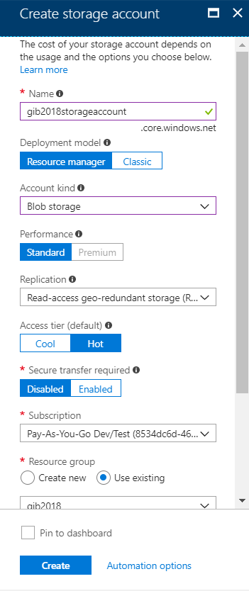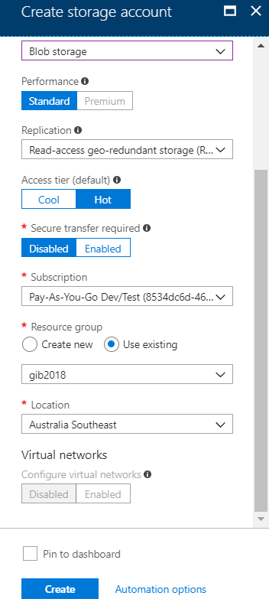

**Part 3 – Create a Stream Analytics Job**

1. Click **+ Create a resource** -> Search for **Stream Analytics** -> Select the first **Stream Analytics** option -> Click **Create**.
2. Enter the following information:
   * **Name**: Name your Stream Analytics job
   * **Subscription**: Same as IoT Hub’s
   * **Resource** **group**: Same as IoT Hub’s
   * **Location**: Australia Southeast
3. Click **Create**.

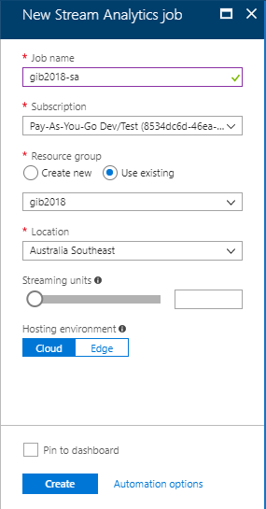

**Part 4 – Set-up Stream Analytics**

1. Go to **Stream** **Analytics**. (**Resource** **groups** -> your Resource group -> **Stream** **Analytics** job created in Part 3).
2. Click **Inputs** -> **+** **Add** **stream** **input** -> **IoT Hub**.

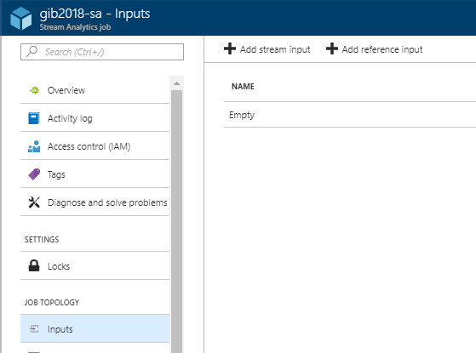

1. Enter the following details:

Use your own subscription and select the IoT Hub you created in Part 1.

Click **Save**.

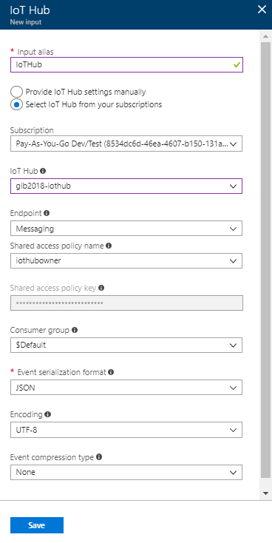

1. Click **Outputs** -> **+** **Add** -> **Blob storage**.
2. Enter the following details:

Use your own subscription and select the Blob Storage you created in Part 2.

Click **Save**.

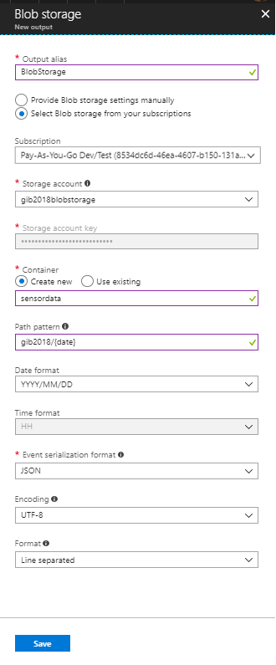

1. Go to **Query**. Replace **[YourOutputAlias]** with **[BlobStorage]** and **[YourInputAlias]** with **[IoTHub]**. Click **Save**.

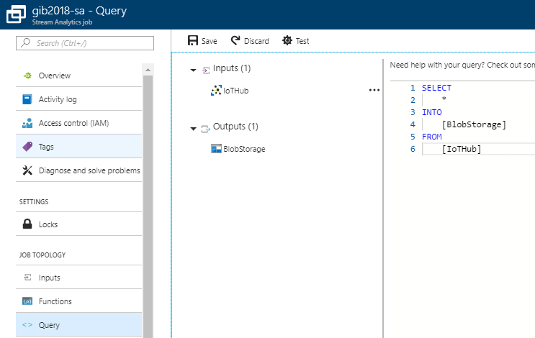

1. Go to **Overview** -> click **Start**.

**Part 5 – Connecting Simulated Devices to IoT Hub using UWP (Universal Windows Platform).**

1. Open the **Global_Integration_Bootcamp_IoT.sln** file.
2. Open **AzureIoTHub.cs**.

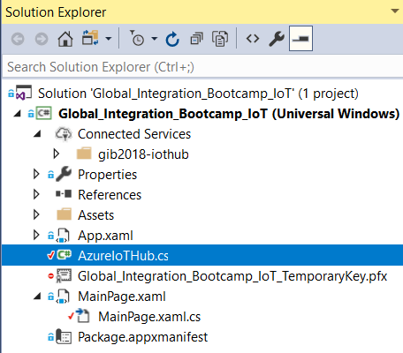

1. Go to **Azure** **Portal** (portal.azure.com) -> your **IoT** **Hub** -> **IoT** **Devices** -> **humidity** -> Copy the **primary** **key** **connection** **string**.

Go back to **AzureIoTHub.cs** -> replace **{Humidity Connection String}** with the connection string you just copied.

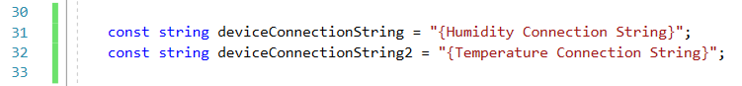

Repeat for temperature. Replace **{Temperature Connection String}**.

1. Click to run the application.
2. Press either one of the buttons to send the current value of a specific sensor device to IoT Hub.

**Part 6 – Checking IoT Hub and Blob Storage.**

Go to **Azure** **Portal** (portal.azure.com) and open your **IoT** **Hub**.

If you clicked **send** in Part 5, you should be able to see how many messages you have sent so far. (You might need to wait a bit just in case there’s any delay.)

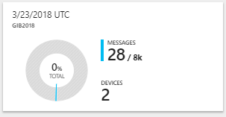

Now, go to **Stream** **Analytics** and see the Input and Output spikes in the **Monitoring** section/graph. (Again, the messages from IoT Hub might take a few minutes to arrive just like below). Once you see that there is at least one output event, go to your **Blob** **storage**.

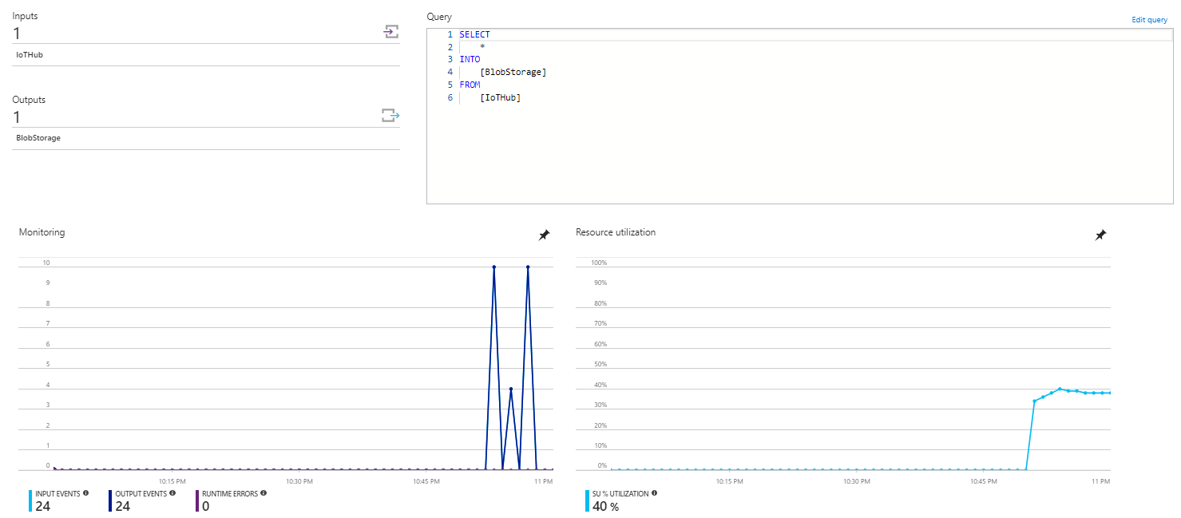

From your **Blob** **storage** page -> Click **Blobs** -> **sensordata** -> **gib2018** -> **2018** -> **03** -> **23** (or **24**) -> click on the **.json** file -> **Download**.

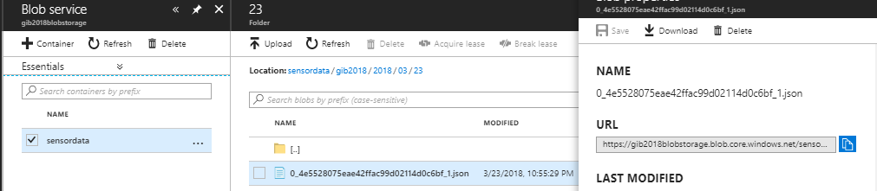



**Finally, don’t forget to stop your Stream Analytics when not in use to prevent charges.**